
Health Screening Form
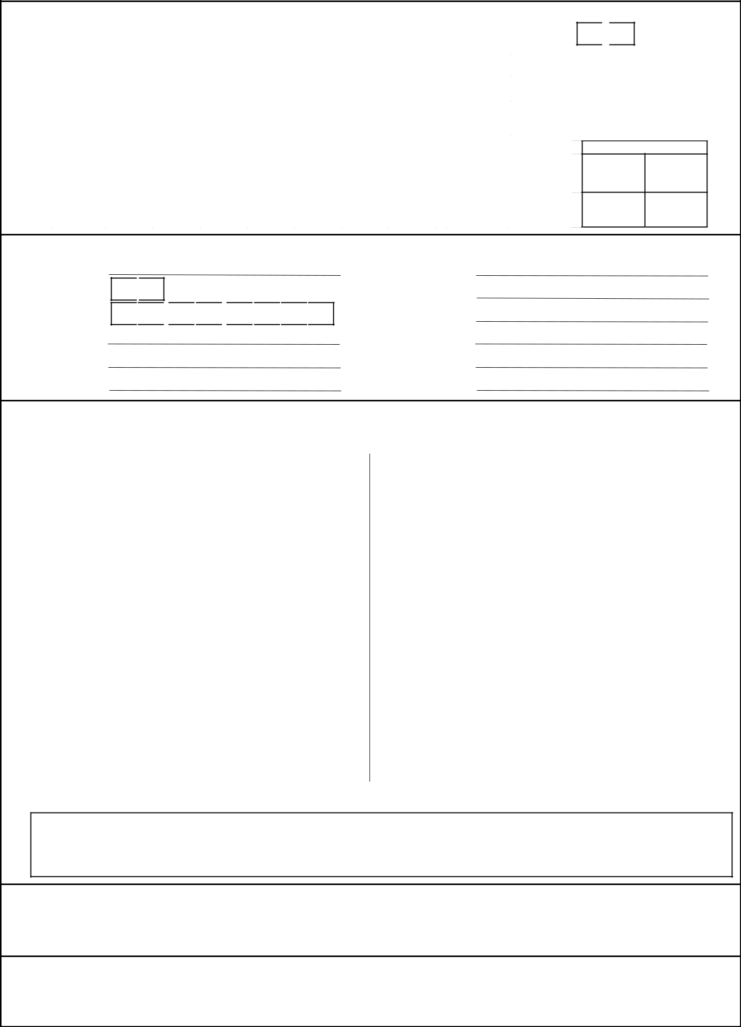

- Type Of Health Screening

Periodical |  |  |  |  | Pre-Employment |  |  |  |  |  |  |  | 40 Yrs or below |  | M |  |  | F |  | Above 40 Yrs
 |  | Pre-employment & Periodic Health Examination |  |  |  |  |  |  |  |  |  |  |  |  |  |  |  | Pre-employment -
 |  |  |  |  |  |  |  |  |  |  |  |  |  |  |  |  |  | Additional Test
completion |  | Tests |  | Blood |  | Urine |  | Stool |  | Audiometry |  | Chest X-ray | ECG | Vision/Eye |  |  |  | Drug screening
completion |  | Check for
 |  | Completion
for
for |  | Additional Health Screening above 40 Yrs - Pre-employment & Periodic Health Examination |  |  |  |  |  |  |  |  |  |  |  |  |  |  |  | Additional Test - Males Above 40 Yrs
for |  |  |  |  |  |  |  |  |  |  |  | USG
Check |  |  |  |  |  |  |  |  |  |  | Alkaline | USG |  | Cardiac |  |  |  |  |  | Prostate
Check |  |  |  |  |  |  |  |  |  |  | Alkaline | and pelvis) |  |  |  |  |  |  |  | Prostate
 |  | Tests |  | Tonometry |  | CEA |  | TSH |  |  | Alkaline | (Abdomen | PFT |  |  |  |  | PSA |  | Prostate
 |  |  |  | Tonometry |  | CEA |  |  |  | Phosphatase |  | (Abdomen | PFT | Stress test |  |  |  |  |  | Ultrasound
 |  | Check for
 |  | Completion

M F

Additional Test - Females Above 40 Yrs

PAP Smear
Mammogram
(Optional)

- Personal Information

Name

Gender

Date of Birth

Employee No.

Job Title

City

M F
D D M M Y Y Y Y

Nationality

Company Name

Work Location

E-mail Address

Contact No.

Contact Address

- Medical History: Please answer the following to the best of your knowledge

Is there any past/present history of any of the |  | Cadidates
following
1) | Ear / Nose / Throat Problem | Y |  | N
2) | Allergy / Hay Fever | Y |  | N
3) | Skin Disease/ Psoriasis | Y |  | N
4) | Hearing Impairment/Ear Discharge | Y |  | N
5) | Heart Disease | Y |  | N
6) | Stomach / Bowel Disorders | Y |  | N
7) | Gall Stones / Kidney Disorders | Y |  | N
8) | Fits / Epilepsy / Dizziness / Fainting | Y |  | N
9) | Head Injury / Concussion / Loss of Memory | Y |  | N
10) | Nervous / Mental disease / Sleep disorder | Y |  | N
11) | Headaches / Migrane | Y |  | N
12) | Piles / Varicose veins | Y |  | N
13) | Blood Disorder | Y |  | N
14) | Female Disorders | Y |  | N
15) | Allergies / Current Medications : | Y |  | N

Is there any past/present history of any of the |  | Cadidates
following
16) | Eye / Vision Problems / Glaucoma | Y |  | N
17) | Asthma / Bronchitis / Tuberculosis | Y |  | N
18) | High/Low Blood Pressure | Y |  | N
19) | Diabetes | Y |  | N
20) | Jaundice / Liver Disease | Y |  | N
21) | Fracture / Dislocation / Injury / Amputation | Y |  | N
22) | Joint Pain/Spinal Trouble | Y |  | N
23) | Major / Minor Operation | Y |  | N
24) | Infection / Contagious Disease | Y |  | N
25) | Addiction to alchohol / drugs / tobacco | Y |  | N
26) | Malignant Disease (Cancer) | Y |  | N
27) | Hernia / Hydrocoele / Appendictis | Y |  | N
28) | Lump In breast/Gynecological treatment | Y |  | N
29) | Signed off on medical ground/Declared Unfit | Y |  | N

Please include any other medical condition that may not have been mentioned:

- Occupational History : (Have you been exposed to)

a) Mercury | Y |  | N |  |  |  | b) Radioactivity |  |  | Y |  | N | c) Excessive noise | Y |  | N |  | d) Toxic Chemicals | Y |  | N
e) Any other occupational hazard |  |  |  |  | Y |  | N |  |  |  |  |  | If Yes please specify

E FAMILY HISTORY:

Document code: FIPL/HMP/0065/V.1 Page 1 of 3


Health Screening Form

To be completed by Hospital/Medical Center


- PHYSICAL EXAMINATION

a) Height (cms) |  |  |  |  | b) Weight (Kgs) |  |  |  |  |  | c) Pulse (/Min)
 |  |  |  |  | Respiratory |  |  |  |  |  |  |  |  |  |  |  |  |  |  |  |  | Diastolic
d) Temperature |  |  |  |  | ^{f)} rate |  |  |  |  |  | e) Blood Pressure | Systolic |  |  |  |  |  |  |  |  |  | Diastolic

- SYSTEMIC EXAMINATION (Please Tick the Normal / Abnormal)

Normal | Abnormal | Comments | Normal | Abnormal | Comments

- Head & Neck

- Ears / Nose / Throat

- Eyes

- ^{Teeth}_{Cavity} ^{& Oral}

- Lungs & Chest

- Musculoskeletal

- Respiratory System

- Abdomen

- Genito-urinary system

- Skin and varicose veins

_{f)} Cardiovascular |  |  |  |  |  |  |  | n) Anus & Rectum
 | System
g) Neurological |  |  |  |  |  |  |  | o) Hernia
h) Breast
 | Others:

 |  | H INVESTIGATIONS |  |  |  |  | H1-H2 Audiometry |  |  |  |  |  |  |  |  |  |  |  |  |  |  |  |  |  |  |  | Normal |  |  |  |  |  | Abnormal |  |  |  | Low (0.5,1,2 kHz) |  |  |  |  |  |  |  | High (3,4,6 kHz)
1) |  |  | H1-H2 Audiometry |  |  |  | Right Ear
 |  |  |  |  |  |  | Left Ear
2) |  |  | Vision
 |  |  |  |  |  |  | Vision |  |  |  |  |  |  |  |  |  |  |  |  |  |  |  |  | Distance |  |  |  |  |  |  |  |  | With Correction |  |  |  |  |  | Near |  |  |  |  |  | With Correction
 |  |  |  |  |  |  | Right Eye |  |  |  |  |  |  |  |  |  |  |  |  |  |  | /6 |  |  |  |  |  |  |  |  |  |  |  |  |  |  | N
 |  |  |  |  |  |  | Left Eye |  |  |  |  |  |  |  |  |  |  |  |  |  |  | /6 |  |  |  |  |  |  |  |  |  |  |  |  |  |  | N
 |  |  |  |  |  |  |  |  |  |  |  |  |  |  |  |  |  |  |  |  |  |  |  |  |  |  |  |  |  |  |  |  |  |  |  |  |  |  | Normal |  |  |  |  |  | Abnormal
 |  |  |  |  |  |  | Right Visual Fields
 |  |  |  |  |  |  | Left Visual Fields
 |  |  |  |  |  |  | Colour Blindness- Ishihara
3) |  |  | Cardiac Function
 |  |  |  |  |  |  | Normal |  |  |  |  |  |  |  |  |  |  | Abnormal |  |  |  |  |  |  |  |  |  |  |  |  |  |  |  |  |  |  | Remarks
 |  |  | ECG General
4) |  |  | Imaging |  |  |  | Normal |  |  |  |  |  |  |  |  |  |  | Abnormal |  |  |  |  |  |  |  |  |  |  |  |  |  |  |  |  |  |  | Remarks
 |  |  | Chest X-ray
5) |  |  | Urine |  |  |  |  |  |  |  |  | Normal |  |  |  |  |  |  |  |  |  |  | Abnormal |  |  |  |  |  |  |  |  |  | F) Stool |  |  |  |  |  | Normal |  |  | Abnormal
 |  |  | Albumin |  |  |  |  |  |  |  |  |  |  |  |  |  |  |  |  |  |  |  |  |  |  |  |  |  |  |  |  |  |  | Parasite
 |  |  |  |  | Sugar |  |  |  |  |  |  |  |  |  |  |  |  |  |  |  |  |  |  |  |  |  |  |  |  |  |  |  |  |  |  | Blood
 |  |  |  |  |  | Blood |  |  |  |  |  |  |  |  |  |  |  |  |  |  |  |  |  |  |  |  |  |  |  |  |  |  |  | Others
 |  |  |  | Others
 |  |  |  |  |  |  |  |  |  |  |  | Normal |  |  |  |  |  |  |  |  |  |  | Abnormal |  |  |  |  |  |  |  |  |  |  |  |  |  |  |  | Remarks
6) |  |  | BLOOD TEST
 |  |  | DRUG SCREENING |  |  |  |  |  |  |  |  | Normal |  |  |  |  |  |  |  |  |  |  |  | Abnormal |  |  |  |  |  |  |  |  |  |  |  |  |  |  | Remarks
7)
 |  |  | (Pre - Employment only)
 |  | FOR ALL CANDIDATE ABOVE 40 Yrs |  |  |  |  |  |  |  |  |  |  |  |  |  |  |  |  |  |  |  |  |  | Abnormal |  |  |  |  |  |  |  |  |  |  |  |  |  |  | Remarks
 |  |  |  |  |  |  |  |  |  |  |  | Normal
8) |  |  | Tonometry
9) |  |  | CEA (carcinoembroyonic Ant
 |  | 10) TSH
 |  | 11) Alkaline Phosphatase
Document code: FIPL/HMP/0065/V.1 |  |  |  |  |  |  |  |  |  |  |  |  |  |  |  |  |  |  |  |  |  |  |  |  |  |  |  |  |  |  |  |  |  |  |  |  |  |  |  |  |  |  |  |  |  |  | Page 2 of 3

 |  |  |  |  |  |  |  |  |  |  |  |  | Health Screening Form
 |  |  |  |  |  |  |  |  |  |  | To be completed by Hospital/Medical Center
 |  |  |  |  | Normal |  |  |  |  |  | Abnormal |  |  | Remarks
 | 12) USG (abdomen & Pelvis)
 | 13) Spirometry (PFT)
 | 14) Cardiac Stress test
 | Additional For MEN ABOVE 40 Yrs |  |  |  | Normal |  |  |  |  |  | Abnormal |  |  | Remarks
 | 15) PSA
 | 16) Prostate Ultrasound
 | Additional For WOMEN |  |  |  |  |  |  |  |  |  | Abnormal |  |  | Remarks
 |  |  |  |  | Normal
 | 17) Mammogram
 | 18) PAP Smear ( optional)
 | I Health parameter checked |  |  |  |  |  |  | Abnormal |  |  |  |  |  | Remarks
 |  |  |  |  | Normal
 |  | GENERAL CONDITION
 |  | COMPLETE BLOOD COUNT
 |  | HYPERTENSION
 |  | CARDIAC STATUS
 |  | EYE/VISION CHECKS
 |  | EAR/HEARING
 |  | LIPID PROFILE
 |  | LIVER PROFILE
 |  | RENAL PROFILE
 |  | RESPIRATORY
 |  | (SPIROMETRY)
 |  | SEROLOGY
 |  | DRUG TEST
 |  | USG
 |  | X-RAY
 |  | URINE
 |  | STOOL
 |  | FEMALE SPECIFIC TEST
 |  | COMMENT BY EXAMINING PHYSICIAN:


FIT IN ALL AREAS

FURTHER ASSESSMENT IF REQUIRED

RESTRICTION REQUIRED

Y |  | N
Y |  | N |  | (if yes please comment)
Y |  | N |  | (if yes please comment)

COMMENT : (UNFIT/ FURTHER ASSESSMENT/RESTRICTION REQUIRED)

DETAILS OF EXMINING PHYSICIAN
DETAILS OF EXMINING PHYSICIAN | Stamp / seal
Doctor's Name : | Stamp / seal
Clinic Name :
Address :
Signature & Date:

Document code: FIPL/HMP/0065/V.1 Page 3 of 3

